DeVry University – EET 202L (^Laboratory Report Cover Sheet)

Experiment / Assignment #5
Design of Synchronous Counters Using Classical Design

Name(s)  Justin Knox | Professor: Ron Surprenant
*Summary (two sentences):

________________________________________________________________________
*Report Checklist (Include the following sections in your report):
1. Introduction & Background |  | 4. Results: Data, Tables, & Diagrams
2. Procedure |  | 5. Analysis of Results
3. Troubleshooting & Testing |  | 6. Conclusions
*Key Results:

________________________________________________________________________
Deliverables: All sections that contain a deliverable are identified with an ^.
- This Lab. Report Cover Sheet with Summary & Key Results responses.
- Section IV-2: Complete State Diagram
- Section IV-3: Complete State Table
- Section IV-4: Complete Karnaugh Map with Instructor Sign-Off.
- Section IV-5: Completed circuit schematic of Figure 5.6
- Section IV-6: Circuit demonstration & Instructor Sign-Off.
- V: Questions.
- Lab Report
Signatures: | Date Submitted:

I. OBJECTIVES
- To use classical design techniques to design a synchronous counter with a non-binary count sequence.
- To build and test the counter.

II. PARTS LIST
Equipment:
Agilent E3631A Triple Output DC Power Supply
Hewlett Packard HP54600B Oscilloscope
Hewlett Packard HP33120A 15MHz Function Generator
Parts:
1 – 74LS04 hex Inverter 3 – LEDs
1 – 74LS08 quad AND gate 1 – 1.0 kΩ resistor, ¼ W, 5%
1 – 74LS86 quad EXOR gate 3 – 330 Ω resistors, ¼ W, 5%
2 – 74LS112 dual J-K flip-flop 2 – 74LS32 quad OR gate

INTRODUCTION
The classical design of synchronous counters is based on utilization of the current state-next state conditions of the counter, combined with flip-flop excitation tables to create the resultant Boolean expressions for the flip-flop inputs. This technique is discussed in the Floyd textbook beginning on page 529 (page 376 in the Dueck textbook).
As discussed in the text, the design technique involves several steps. These are:
- Define the problem, namely the count sequence desired.
- Draw a State Diagram showing the count sequence.
- Create a State Table listing all of the possible Current States and the desired Next States as articulated in the State Diagram.
- Use the appropriate flip-flop Excitation Table to determine the required values of the inputs to make the circuit transition from each Present State to the desired Next State.
- Simplify the expressions from the Excitation Table to derive the minimum Boolean equations for each flip-flop input.
- Draw the required logic circuit.
In this lab, this technique will be utilized to design, build and test a 3-bit Gray code counter using J-K flip-flops.

PROCEDURE
- The 3-bit Gray code sequence is shown in Figure 5.1.
0 0 0
0 0 1
0 1 1
0 1 0
1 1 0
1 1 1
1 0 1
1 0 0
Figure 5.1 – 3-Bit Gray Code
- *Complete the State Diagram in Figure 5.2 for the Gray Code counter.
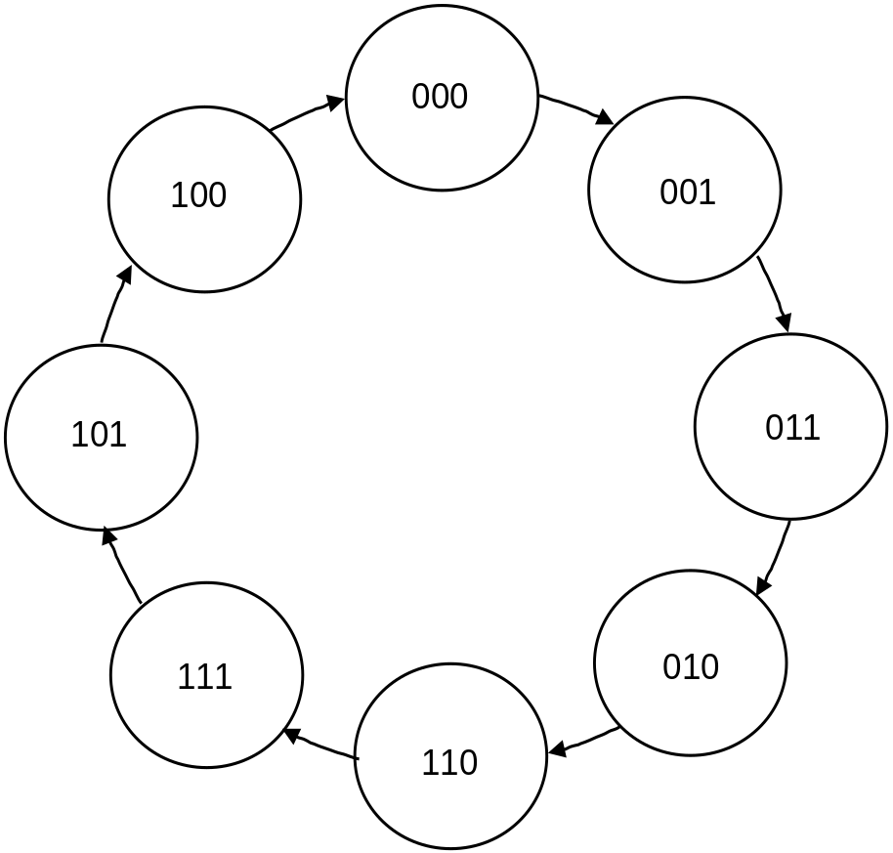

Figure 5.2 – State Diagram for 3-Bit Gray Code Counter

- *Using the J-K Transition Table shown in Figure 5.3, complete the State Table in
Figure 5.4.

Transition | J K
0 → 0 | 0 X
0 → 1 | 1 X
1 → 0 | X 1
1 → 1 | X 0

Figure 5.3 – J-K Flip-Flop Transition Table

Present State | Next State | Synchronous Inputs
Q₂ Q₁ Q₀ | Q₂ Q₁ Q₀ | J₂ K₂ | J₁ K₁ | J₀ K₀
0 0 0 | 0 0 1 | 0 X | 0 X | 1 X
0 0 1 | 0 1 1 | 0 X | 1 X | X 0
0 1 1 | 0 1 0 | 0 X | X 0 | X 1
0 1 0 | 1 1 0 | 1 X | X 0 | 0 X
1 1 0 | 1 1 1 | X 0 | X 0 | 1 X
1 1 1 | 1 0 1 | X 0 | X 1 | X 0
1 0 1 | 1 0 0 | X 0 | 0 X | X 1
1 0 0 | 0 0 0 | X 1 | 0 X | 0 X

Figure 5.4 – 3-Bit Gray Code State Table
- *Transfer the results from the State Table to the Karnaugh maps shown in Figure 5.5 for each of the inputs to the flip-flops. Simplify the equations and write the results in the spaces indicated. Have your instructor sign-off this step, before you begin to build the circuit.

0 1
0 0 0 1 1 1 1 0
Q₀
Q₂Q₁
0 1
0 0 0 1 1 1 1 0
Q₀
Q₂Q₁

J₂ = K₂ =
0 1
0 0 0 1 1 1 1 0
Q₀
Q₂Q₁
0 1
0 0 0 1 1 1 1 0
Q₀
Q₂Q₁

J₁ = K₁ =
0 1
0 0 0 1 1 1 1 0
Q₀
Q₂Q₁
0 1
0 0 0 1 1 1 1 0
Q₀
Q₂Q₁

J₀ = K₀ =

Figure 5.5 – Karanugh Map Simplification for 3-Bit Gray Code Counter

Instructor Sign-off ________________

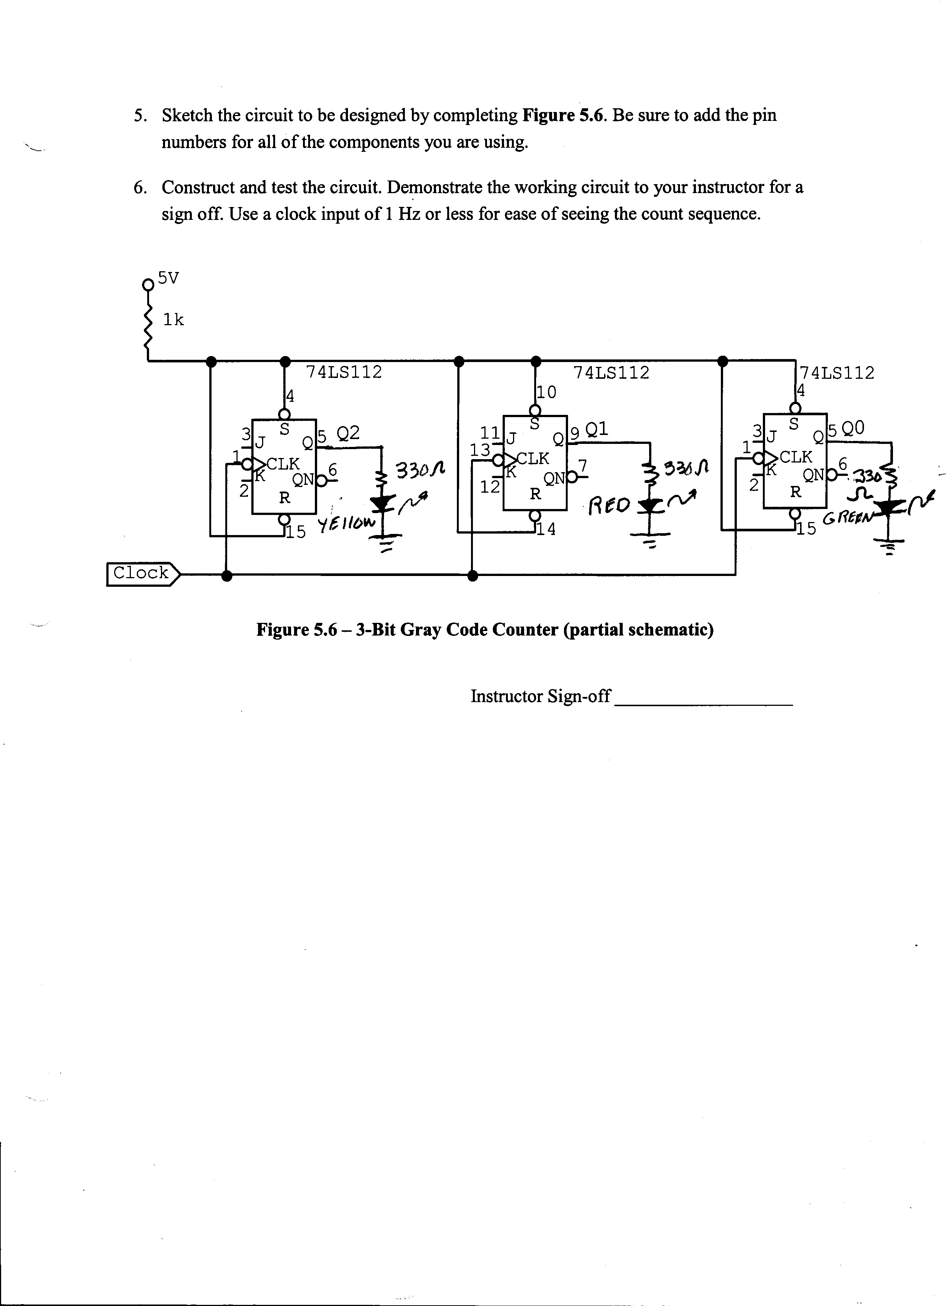

V. *QUESTIONS
- In general, why are J-K flip-flops preferred over D flip-flops for counters designed using classical techniques?
Typically when a JK flip flop is creatively implemented from its’ derived Boolean equations, they take less gates to implement. However, D flip flops contain only one input therby increasing the complexity of their logical arrangement. This is because in the D flip Flop equations, there are never going to be any “don’t cares” or “x” inputs.
- Draw the Transition Table for a D flip-flop.

Transition | D Input
0 → 0 | 0
0 → 1 | 1
1 → 0 | 0
1 → 1 | 1

- Derive the equations required for the 3-bit Gray code counter using D flip-flops instead of J-K flip-flops.
Present State | Next State | Synchronous Inputs
Q₂ Q₁ Q₀ | Q₂ Q₁ Q₀ | D₀ | D₁ | D₂
0 0 0 | 0 0 1 | 0 | 0 | 1
0 0 1 | 0 1 1 | 0 | 1 | 1
0 1 1 | 0 1 0 | 0 | 1 | 0
0 1 0 | 1 1 0 | 1 | 1 | 0
1 1 0 | 1 1 1 | 1 | 1 | 1
1 1 1 | 1 0 1 | 1 | 0 | 1
1 0 1 | 1 0 0 | 1 | 0 | 0
1 0 0 | 0 0 0 | 0 | 0 | 0

D₀ D₁ D₂
0 1
0 0 0 1 1 1 1 0
Q₀
Q₂Q₁
0 1
0 0 0 1 1 1 1 0
Q₀
Q₂Q₁
0 1
0 0 0 1 1 1 1 0
Q₀
Q₂Q₁
1.) Introduction and Background
This lab is an attempt to verify and experiemtn with the physical creation of a synchrounous JK Flip Flop counter. The intent of this lab is to actually implement the counter using the vaiours techniques that we studied.
2.) Procedure
In order to perform this experiment I did the following actions:
- Created the state diagram for the MOD 8 JK counter.
- Created the appropriate Grey Code State Table for the MOD 8 counter
- Using the transition table, I then solved the karnaugh maps for each of the jk’s flipflops’ various inputs.
- I then used Boolean Algebra to furthermore reduce the complexity of the derived equations, thus creating an easier method for the counters operation.

3.) Troubleshooting and Testing
The most difficult part of this lab experiment was the physical implementation of the counter. After I had created all of my equations and thought that I had everything planned out I started to build the circuit based soley off the diagrams description and my estimates of which gates that I would be using. I found that once I had built my circuit it did not work. Well it worked, but not as I wanted it to. The red green and yellow LED’s were not blinking, they were sputtering. Eventually, every few seconds or so, they would sporadically blink at random and then stop. In order figure out what was happening, I performed the following actions:
- Verified that all of the pins were connected.
- Checked to see that the function generator was set to 1Hz
- Verified that the power supply was in proper operation.
- I followed the cicuit with the oscilloscope, point by point
- I then could not figure out the problem, so I rebuilt the entire circuit.
- Still I could not find out what was going on.
- As a last step, I swapped out the function generator. And found out that the sync on the genereator that I was out was no good.

4.) Results: Data , Tables, & Diagrams

3 Bit Grey Code used by counter
0 0 0
0 0 1
0 1 1
0 1 0
1 1 0
1 1 1
1 0 1
1 0 0
State Diagram
JK Transition Table
Transition | J K
0 → 0 | 0 X
0 → 1 | 1 X
1 → 0 | X 1
1 → 1 | X 0

Figure 5.4 – 3-Bit Gray Code State Table
Present State | Next State | Synchronous Inputs
Q₂ Q₁ Q₀ | Q₂ Q₁ Q₀ | J₂ K₂ | J₁ K₁ | J₀ K₀
0 0 0 | 0 0 1 | 0 X | 0 X | 1 X
0 0 1 | 0 1 1 | 0 X | 1 X | X 0
0 1 1 | 0 1 0 | 0 X | X 0 | X 1
0 1 0 | 1 1 0 | 1 X | X 0 | 0 X
1 1 0 | 1 1 1 | X 0 | X 0 | 1 X
1 1 1 | 1 0 1 | X 0 | X 1 | X 0
1 0 1 | 1 0 0 | X 0 | 0 X | X 1
1 0 0 | 0 0 0 | X 1 | 0 X | 0 X

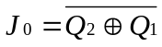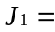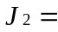
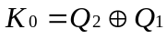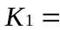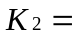
5.) Analysis
Through analyzing my results of this experiemtent I was able to find the following to be true:
- Function Generators cn not always be trusted.
- JK flip flops are surperior to D flip flops when implementing counters
- Counters can be used to implement almost any sequence using their outputs to represent numerical or other typs of data.

6.) Conclusion

In conclusion I noted that counters can contain event sequence codes. Perhaps through using a count enable, a counter could possibly contain a sequence of events to be executed. For example; if a small simplistic BEAM robot was to be situated with an infrared photodiode that was used as a light sensing instrument. Suppose that this diode then gave off a small current when sensing light. The current from the diode would then be used to control a transistor. The transistors output current would control the count enable function of the JK fip flop. If this counter contained the execution codes for a stepper motor, the robot would then move. This is essentially creating a solid state device that would exhibit complicated behavior, while only using basically inert devices.

